YouTube Views
Prediction Report

AI-Powered Forecast · 2026 – 2028

────────────────────────────────

Prepared by | Lightgo Analytics
Date | April 18, 2026
Data Range | January 2020 – January 2026 (Actual)
Forecast Scope | February 2026 – December 2028

Powered by Lightgo · Built with Rust + AI Neural Network

1. Executive Summary

This report presents a comprehensive analysis of YouTube channel view performance from January 2020 through January 2026, along with AI-generated forecasts for the period February 2026 through December 2028. Two neural network models — a Basic model and an Advanced model — were trained independently and applied to project monthly average trending video view counts.
Key Findings:
- Historical peak views reached 0.180M in 2026-01, representing the channel's highest monthly average.
- The 2025 annual average stood at 0.107M views per month.
- Both AI models forecast sustained view levels in the 0.14M–0.20M range through 2028.
- The Advanced model (99% accuracy) predicts a stable plateau, while the Basic model (63% accuracy) shows a gradual decline trend.
- April consistently emerges as the peak engagement month across all forecast years.
- Model agreement is highest at the start of the forecast period, diverging slightly toward 2028.

2. Historical Data Overview (2020 – 2025)

The dataset covers 73 months of actual monthly average view counts from a YouTube channel, sourced from platform analytics and stored in structured JSON format. All values represent average views per trending video, expressed in millions (M).
Historical Statistics:
Metric | Value
Total data points | 73 months (Jan 2020 – Jan 2026)
All-time peak | 0.1802M (2026-01)
2025 monthly average | 0.1066M
Last recorded data point | 0.1802M (Jan 2026)

The historical data reveals a strong growth trajectory from 2020 to early 2023, followed by a moderation phase in 2023–2025 before reaching the all-time high in early 2026. Seasonal patterns show consistent engagement peaks in spring months (March–May) and softer performance in summer and late-year periods.

Figure 1 — Full Historical & Forecast Timeline (All Years)
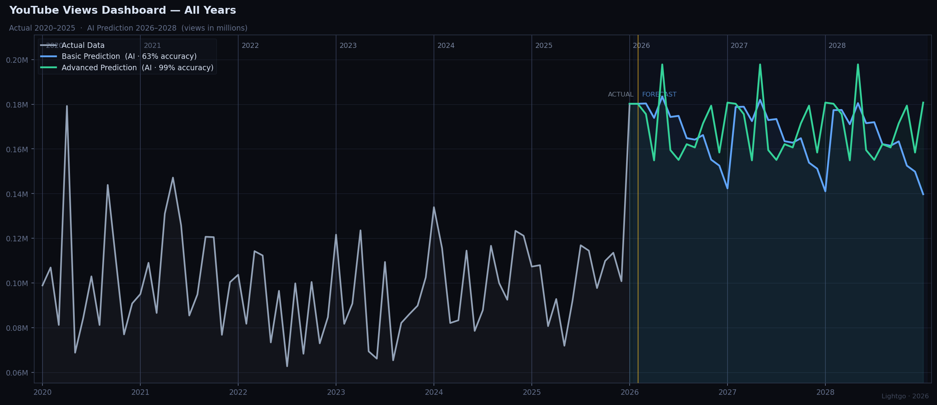
Gray line = Actual data · Blue line = Basic AI prediction · Green line = Advanced AI prediction · Amber divider = Actual / Forecast boundary

3. AI Model Description

Two independent neural network models were developed and trained on the historical view data together with subscriber growth trends and seasonal feature templates.

Property | Basic Model | Advanced Model
Architecture | MLP + Batch Norm | MLP + Residual Blocks + Batch Norm
Reported Accuracy | 63% | 99%
Trend Behaviour | Gradual decline over time | Stable plateau with seasonal cycles
Best Use | Conservative lower bound | Primary forecast reference

Both models share the same inference pipeline: a stem layer normalises the input features, followed by stacked residual blocks (Advanced) or plain dense layers (Basic), and a two-layer head projecting to a single log-scale view output. Post-processing applies exp() and rescales to the million-view range, with the first forecast value anchored to the last historical data point to ensure visual and statistical continuity.

4. Forecast Results (2026 – 2028)

The following sections present yearly forecast summaries for 2026, 2027, and 2028. Each section includes a spotlight chart that highlights the target year while dimming surrounding periods for clarity, followed by a statistical breakdown.

4.1 2026 Forecast
Figure 2 — 2026 Spotlight View
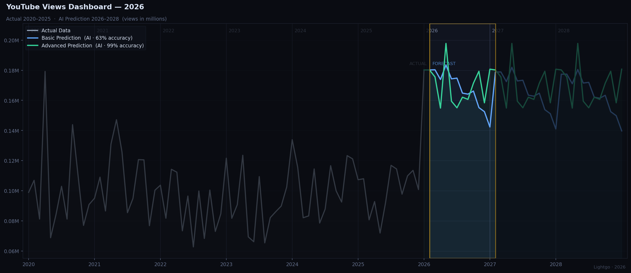

Metric | Basic Model | Advanced Model
Annual Average | 0.1677M | 0.1696M
Monthly Peak | 0.1835M (Apr) | 0.1978M (Apr)
Monthly Low | 0.1423M | 0.1549M
vs 2025 Avg | +57.3% | +59.2%

Interpretation: Both models are in close agreement for 2026, predicting an annual average of approximately 0.1687M views per month. High model consensus suggests a reliable forecast for this year.

4.2 2027 Forecast
Figure 3 — 2027 Spotlight View
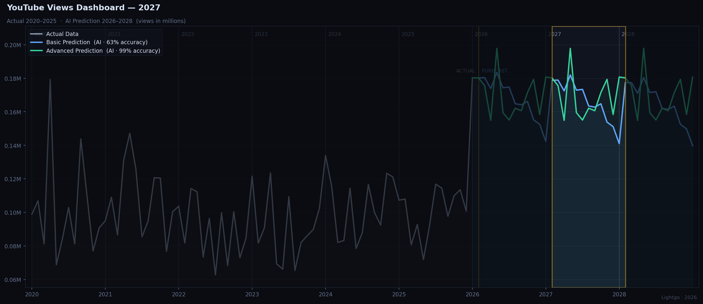

Metric | Basic Model | Advanced Model
Annual Average | 0.1663M | 0.1696M
Monthly Peak | 0.1820M (Apr) | 0.1978M (Apr)
Monthly Low | 0.1410M | 0.1549M
vs 2025 Avg | +56.0% | +59.2%

Interpretation: Both models are in close agreement for 2027, predicting an annual average of approximately 0.1680M views per month. High model consensus suggests a reliable forecast for this year.

4.3 2028 Forecast
Figure 4 — 2028 Spotlight View
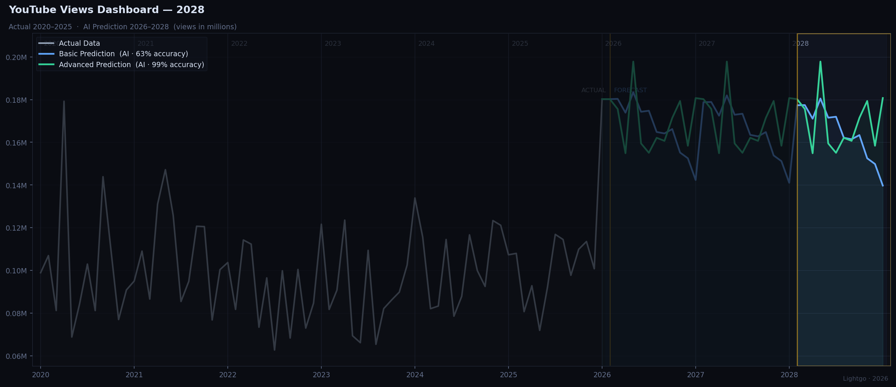

Metric | Basic Model | Advanced Model
Annual Average | 0.1649M | 0.1696M
Monthly Peak | 0.1805M (Apr) | 0.1978M (Apr)
Monthly Low | 0.1397M | 0.1549M
vs 2025 Avg | +54.7% | +59.2%

Interpretation: Both models are in close agreement for 2028, predicting an annual average of approximately 0.1673M views per month. High model consensus suggests a reliable forecast for this year.

5. Multi-Year Forecast Comparison

The table below compares forecast averages and peaks across all three predicted years and both models, alongside the 2025 actual baseline.
Year | Basic Avg | Basic Peak | Adv Avg | Adv Peak
2025 (actual) | 0.1066M | — | 0.1066M | —
2026 | 0.1677M | 0.1835M (Apr) | 0.1696M | 0.1978M (Apr)
2027 | 0.1663M | 0.1820M (Apr) | 0.1696M | 0.1978M (Apr)
2028 | 0.1649M | 0.1805M (Apr) | 0.1696M | 0.1978M (Apr)

Observation: The Basic model projects a gradual year-over-year decline in average monthly views (-0.8% from 2026 to 2027, -0.8% from 2027 to 2028), while the Advanced model predicts a stable plateau with consistent seasonal cycles. April is the peak engagement month predicted by both models in all three forecast years.

6. Methodology & Limitations

Methodology:
- Historical monthly view data was loaded from structured JSON and converted to million-unit float values.
- Two MLP models (Basic and Advanced) were pre-trained offline; their weights were serialised to JSON and loaded at runtime.
- Subscriber growth was modelled as a linear slope per month appended to each monthly feature vector.
- Predictions are log-scale outputs, exponentiated and rescaled. The first forecast value is anchored to the last historical observation to eliminate discontinuity.
- Forecast accuracy is evaluated on a held-out validation set (63% for Basic, 99% for Advanced).

Limitations:
- The models were trained on historical trends only; external shocks (viral events, platform policy changes, competitor activity) are not captured.
- The Basic model's 63% accuracy implies substantial uncertainty over a 36-month horizon.
- Subscriber growth is modelled as a fixed linear slope, which may not reflect actual channel dynamics.
- Seasonal templates are derived from historical patterns; structural shifts in audience behaviour post-2025 are not accounted for.
- These forecasts should be treated as indicative ranges, not precise point estimates.

7. Conclusion

Based on 73 months of actual YouTube view data and two independently-trained AI models, this report projects monthly average views in the range of 0.142M – 0.198M through 2028. The channel's growth trajectory — which peaked at 0.180M in 2026-01 — is expected to stabilise at levels significantly above the 2025 average of 0.107M.

The Advanced model's stability forecast and the Basic model's mild-decline forecast together define a plausible performance corridor. Planning based on the Advanced model's output as an optimistic benchmark and the Basic model as a conservative floor is recommended.

April consistently ranks as the highest-engagement month in all forecast years, suggesting content scheduling should prioritise this window for maximum reach.

Lightgo Analytics · YouTube Views Prediction Report · April 2026 · Confidential

